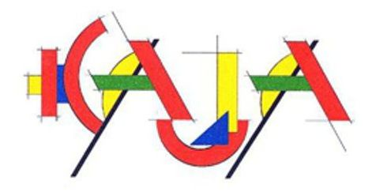
CORPORATE DESIGN GUIDELINES
Creative Art Meeting ON THE MOVE VII
BORDER EXPERIENCES – RESILIENCE BY ART
1. Overall Concept
The visual identity is based on:
- movement (ON THE MOVE)
- transformation and transition
- border experiences
- artistic resilience
The design language should feel:
- dynamic
- modular
- contemporary
- international
This Corporate Design applies to:
- banner
- flyer
- poster
- website
- social media
2. Core Message
The visual communication should convey:
- movement and transformation
- border experiences and crossings
- resilience through artistic expression
- collaboration across cultures
The design should be:
- clear
- strong
- readable (especially in public space)
3. Mandatory Text Elements (Across All Media)
The following elements must be used consistently:
- BORDER EXPERIENCES
- European Creative Meeting
- RESILIENCE BY ART
- ON THE MOVE
- Supraska Academy / Supraśl
- Eastern Poland at the border to Belarus
- 05–19 August 2026
- JOIN US!
- www.kajawest.org
- Co-financed by EU – Erasmus+
4. Visual Concept
A key visual element is the idea of “border experiences”, which can appear symbolically:
- lines
- transitions
- disruptions
- crossings
Typography may also express movement:
- dynamic
- shifting
- layered
- flowing
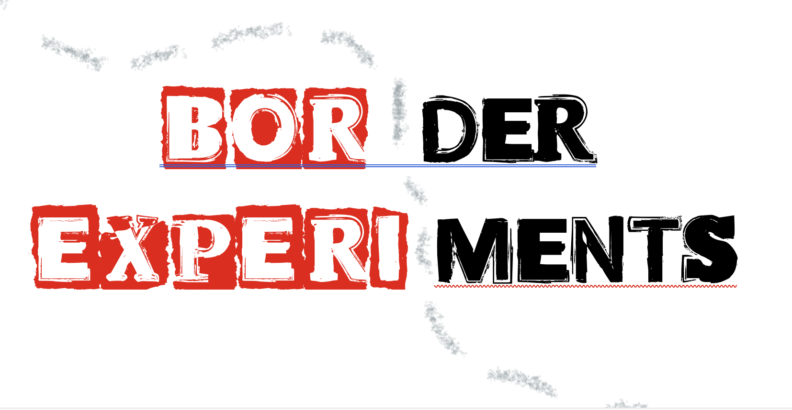
5. Corporate Design – KAJA WEST Identity
The design follows the visual identity of the ON THE MOVE project series.
Colour system:
- light blue / cyan
- sand / beige
- pink / magenta
- violet
- orange accents
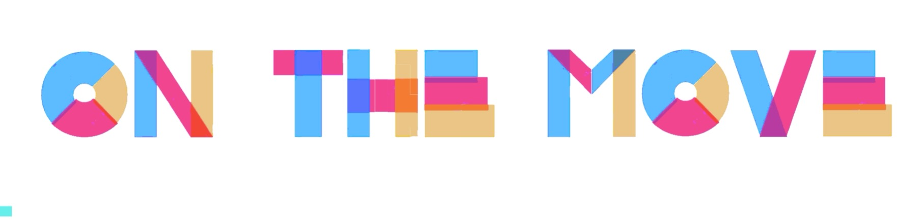
Additionally:
- red–white may be used as a reference to Belarusian democratic identity
- red–green combinations must not be used
- black only for lines and structure
Recommended refinement:
- light mint green in relation to violet
- subtle, European / “British” tone
The overall impression should remain:
- clear
- contemporary
- international
- not folkloristic
- not national-symbolic
6. Typography
Typography: courier new / American typewriter / Arvo should be:
- bold
- readable from distance (banner)
- modular / geometric
Additional Typography may express movement:
- shifting
- overlapping
- fragmented
- layered

Typography Reference: “Alt Bot Tape Font”

Origin and Meaning
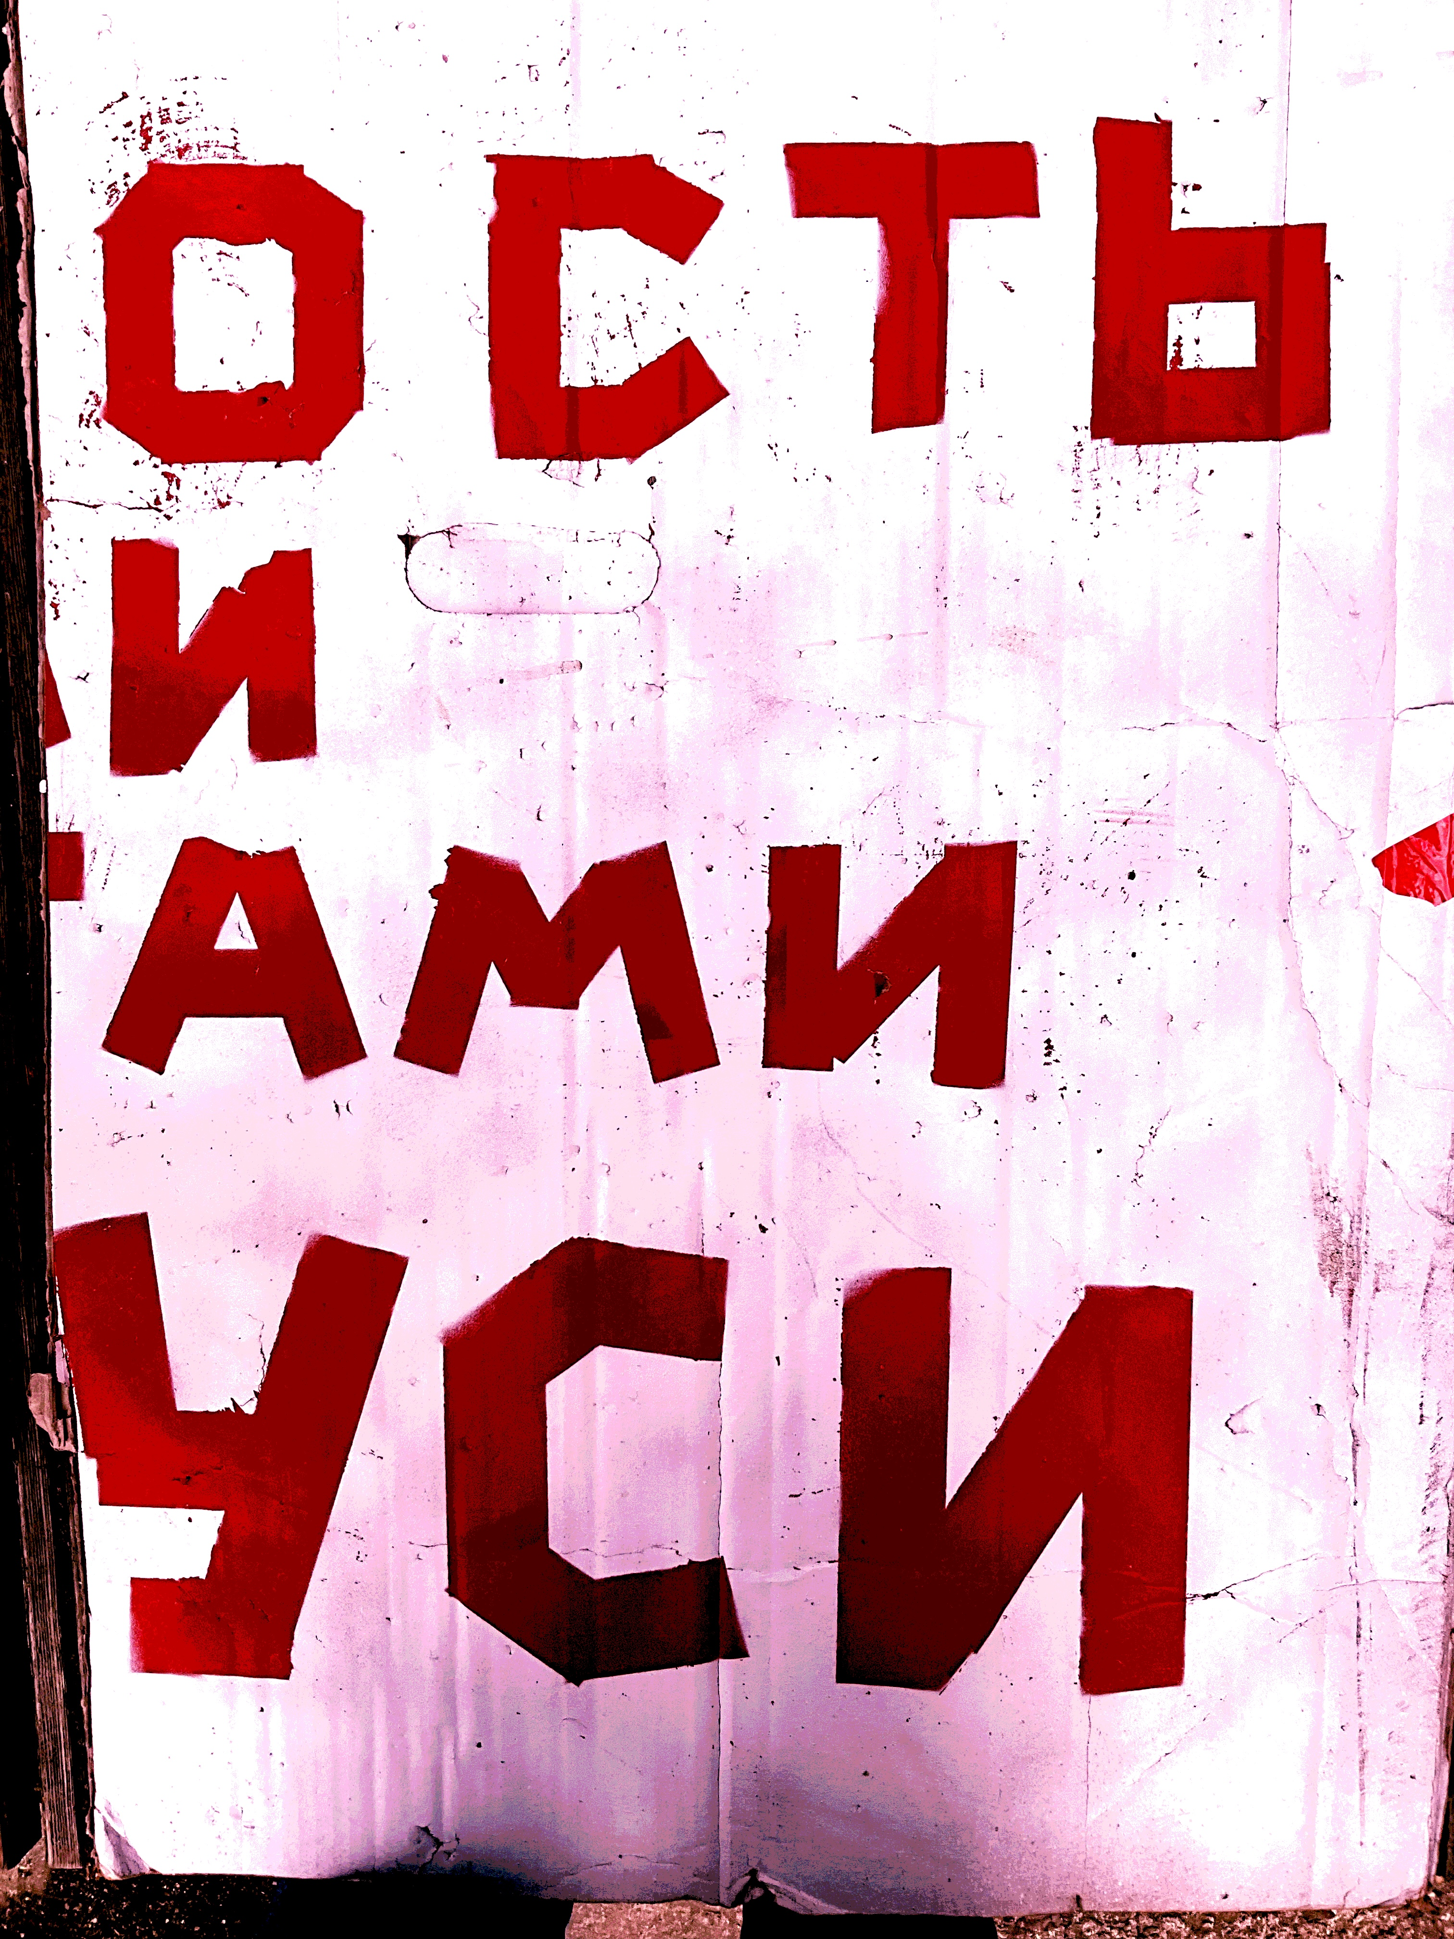
The so-called “Alt Bot Tape Font” originates from protest movements in Berlin against the manipulated elections in Belarus in 2020.
It emerged in a context of:
- political resistance
- urgency
- street-based communication
- limited resources and improvised visual language
👉 The font therefore carries strong symbolic and historical value and should be understood not only as a stylistic choice, but as a visual statement.
Here an exemple of a hybrid font- how it could be used for “borders”
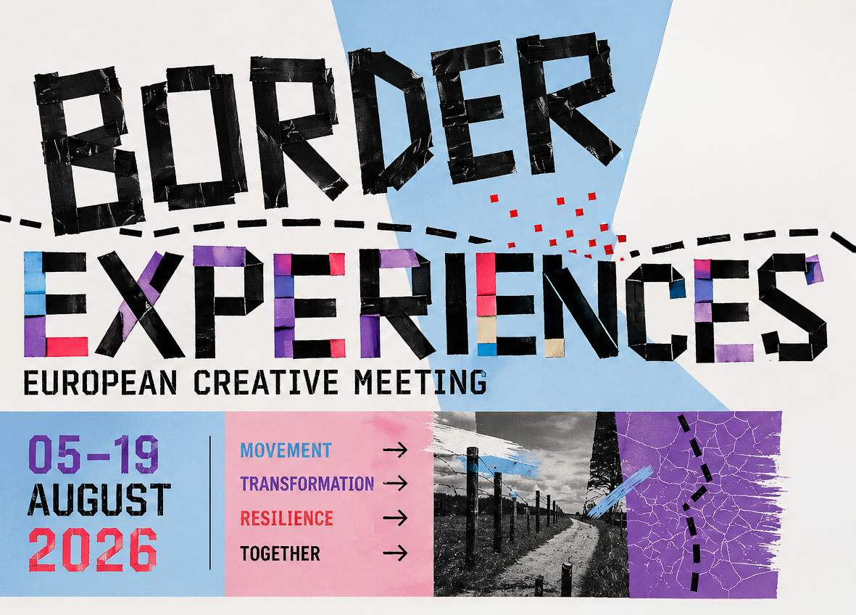
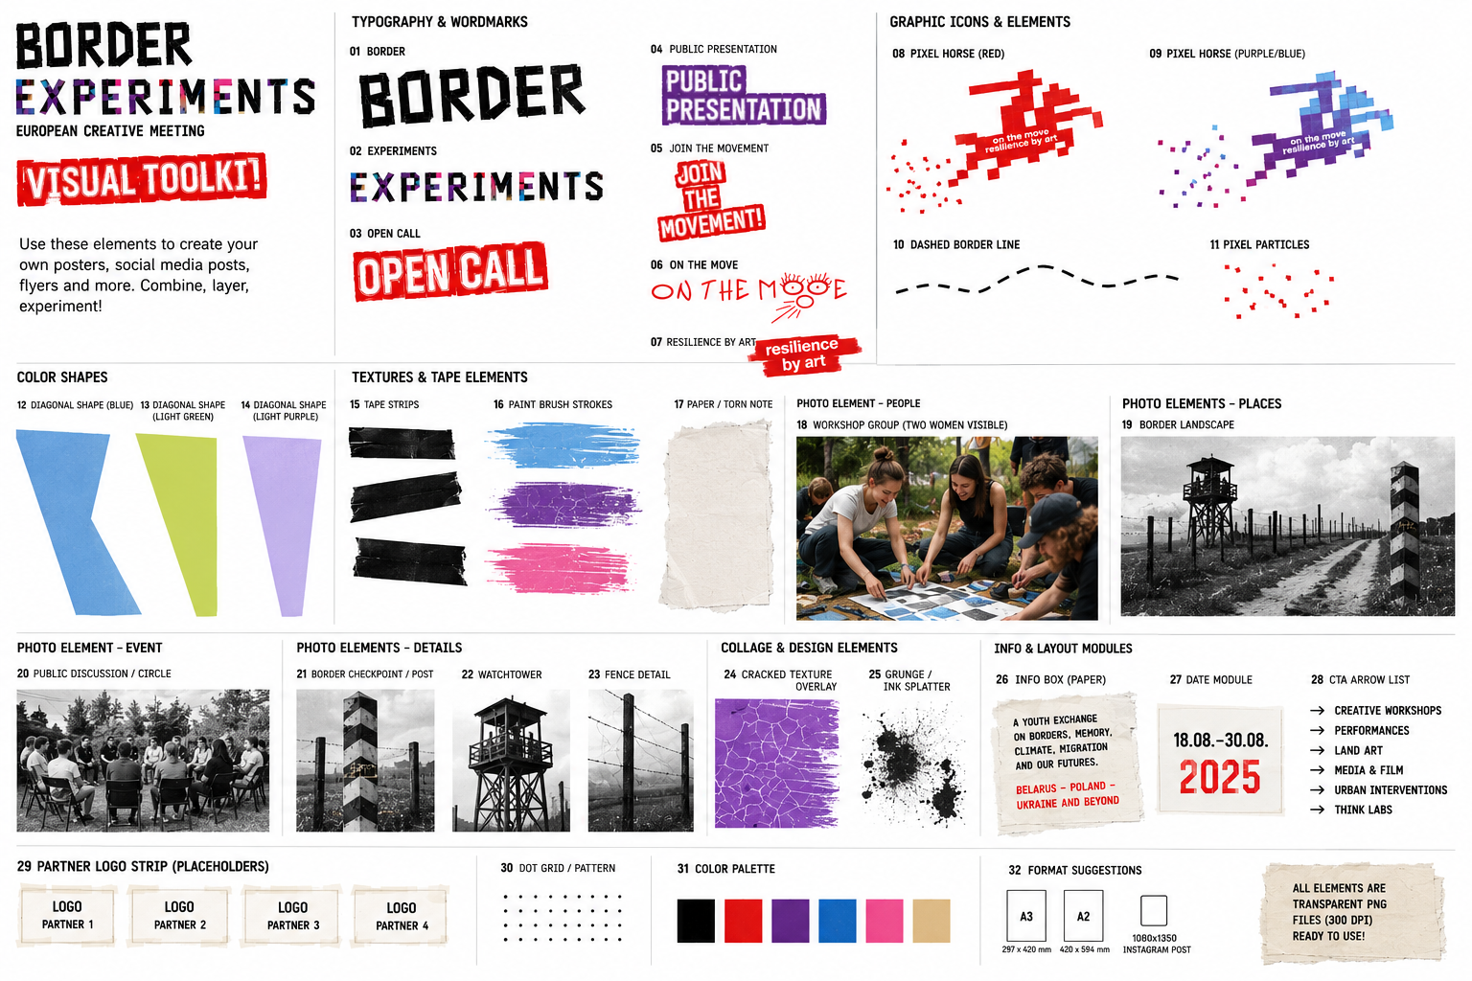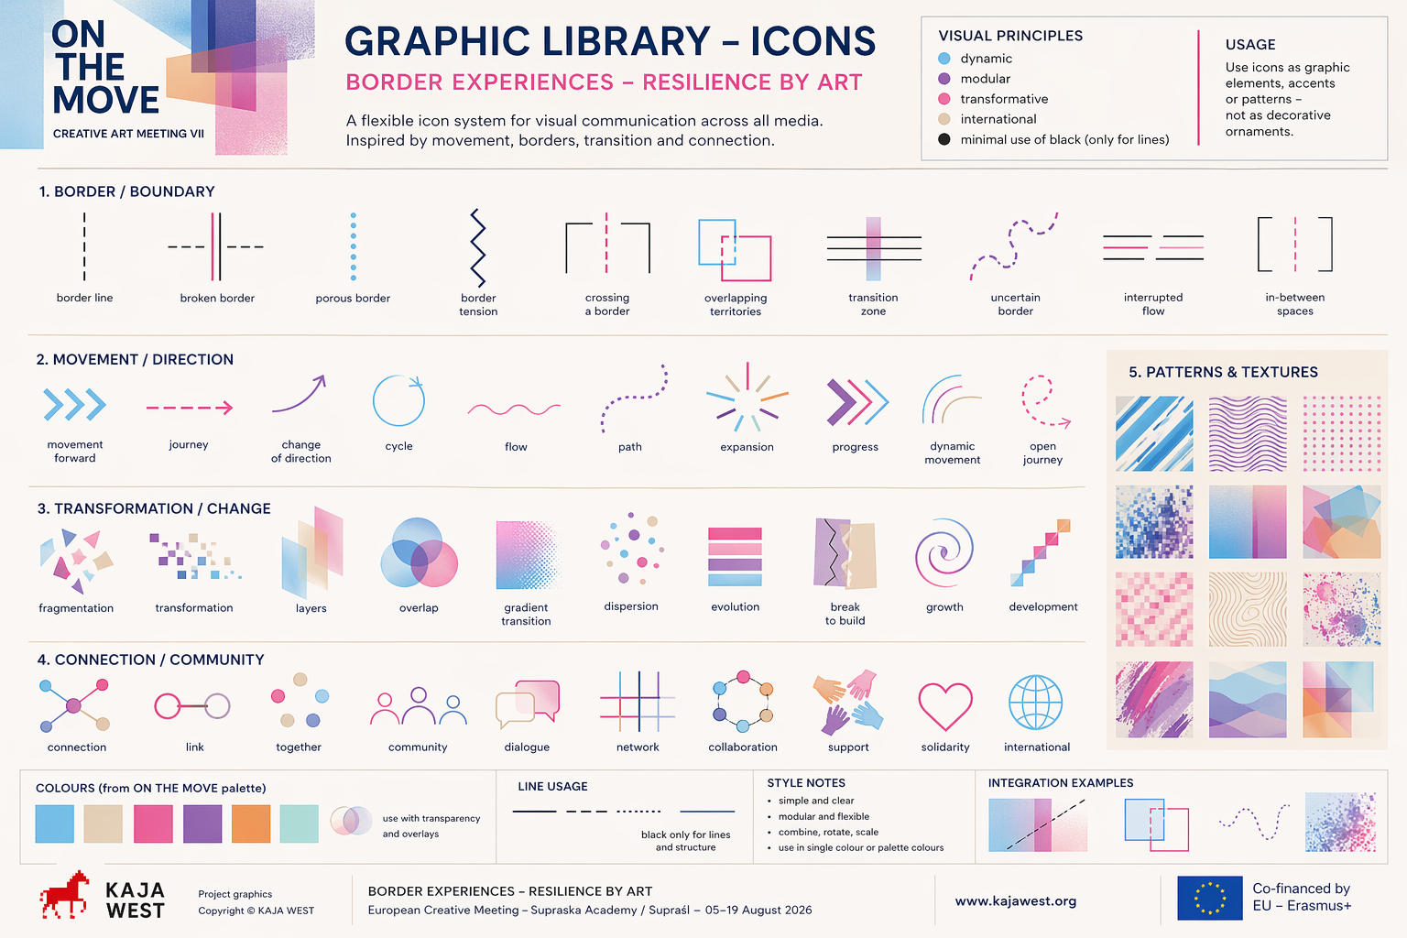

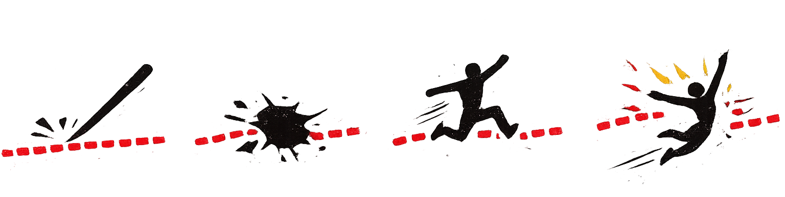
7. Graphic Elements
Illustration / Visual Language:
- borders and transitions
- movement and direction
- transformation processes
- human interaction
- collective action
Icon System:
- dashed line (border)
- broken line (disruption)
- arrow crossing line (transition)
- dissolving line (borderless)
Style:
- minimal
- consistent line thickness
- black or subtle colour accents
- integrated into layout

8. Use of Images and Graphic Material
Only use:
- KAJA WEST images (copyright KAJA)
- KAJA project graphics (red pixel horse / see point 9)
- border-related symbols
New graphics:
- must fit concept and identity
Restrictions:
- no external copyrighted material
- no unrelated stock images
Visual consistency:
- support movement and transformation
- align with ON THE MOVE identity
- integrate with layout
- avoid overload
Recommended:
- combine photography + graphics
- use layering and overlays
- integrate elements into images

9. Project-Specific Graphic Element
A central visual element of the project is:
- the KAJA project logo (“red pixel horse”)
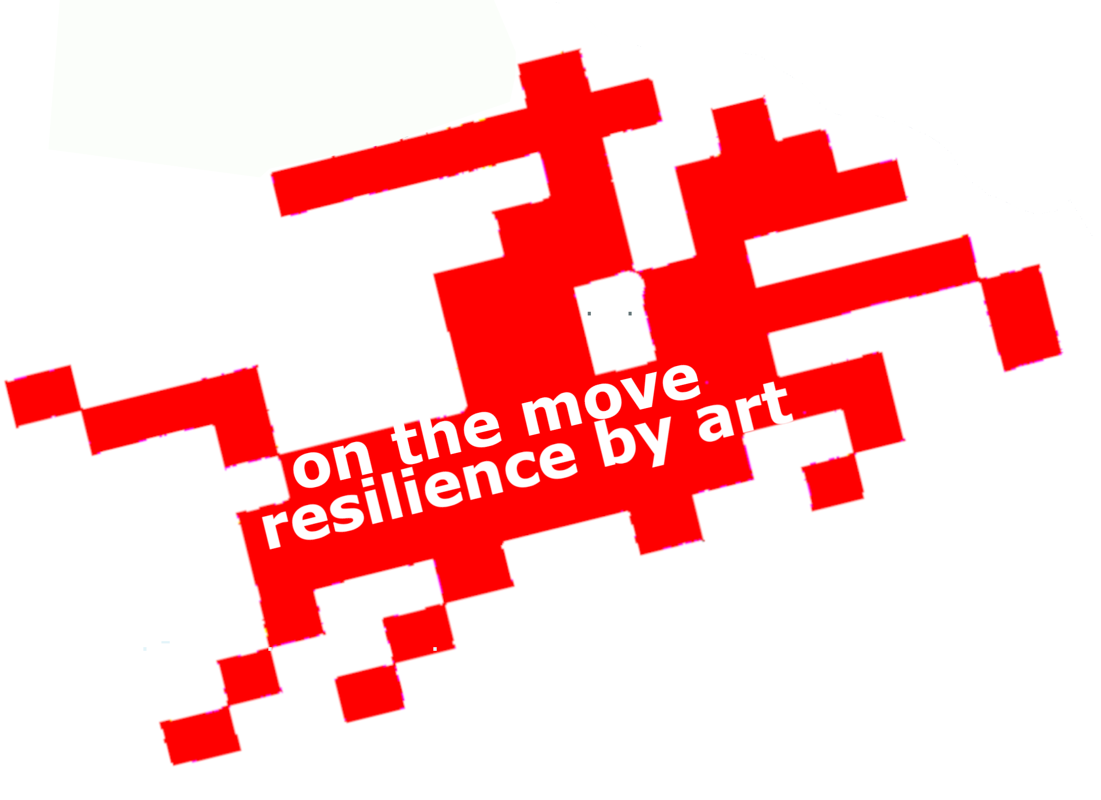
This element represents:
- movement
- resilience
- transformation
- digital + analogue connection

Usage Guidelines
The “red pixel horse” may be used:
- as a main visual element
- as a repeating pattern
- as a fragmented / deconstructed form
- integrated into compositions

Design Approach
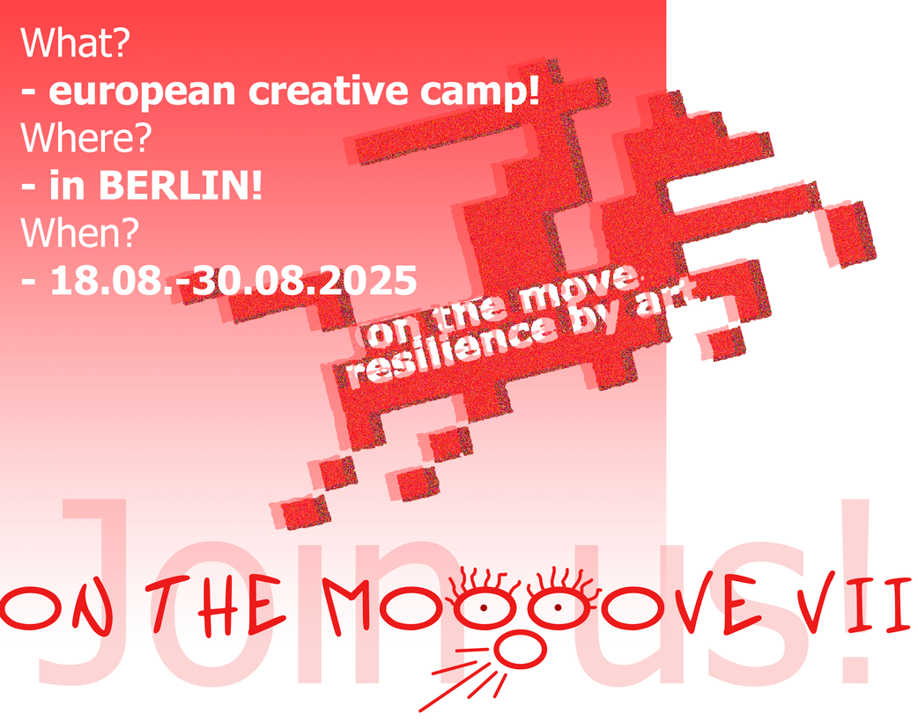
The element can be:
- scaled
- cropped
- layered
- combined with typography
but must remain:
- recognisable

Conceptual Use
The pixel structure may be used to express:
- fragmentation
- movement
- crossing borders
- digital / visual translation

10. Project Structure & Partners
Project Coordinator:
Belarusian-German Organisation KAJA
Regional Cooperation Podlasie:
- Belarusian Cultural Center (ZBK) + LOGO
- Białystok Cultural Centre (BOK) + LOGO
- Mochnarte Foundation + LOGO
- Art College Supraśl+ LOGO
European Partner Context:
- Baltic States
- Belarus
- Poland
- Georgia
- Germany
Funding:
Co-financed by European Union – Erasmus+
11. Logo System
- structured grouping
- consistent spacing
- clear hierarchy
- EU logo slightly separated
Use original colours, no distortion.

